Jenkins Challenge-1
Use the below code and implement our CICD stages.
- Source Code: https://github.com/betawins/hiring-app.git
- Repository contains the application code for the hiring app.

- Create one Declarative pipeline job
Prerequisites:
Make sure you have:
- Jenkins installed (on EC2 or local)
- Java installed
- Git installed
- Maven installed
- Nexus installed
- Tomcat installed
- Slack created
- Jenkins plugins:
Create New Job
1. Login to the Jenkins
2. Click New Item
3. Enter name: declarative-pipeline
4. Select Pipeline
5. Click OK
Add code to the pipeline:
pipeline {
agent any
tools {
maven 'Maven3'
}
environment {
NEXUS_URL = "http://13.60.80.45:8081"
}
stages {
stage('Git Clone') {
steps {
git branch: 'main', url: 'https://github.com/betawins/hiring-app.git'
}
}
stage('Build') {
steps {
sh 'mvn clean package -DskipTests'
}
}
stage('Test') {
steps {
sh 'mvn test'
}
}
stage('SonarQube Analysis') {
steps {
withSonarQubeEnv('sonar') {
withCredentials([string(credentialsId: 'sonar-token', variable: 'TOKEN')]) {
sh '''
mvn sonar:sonar \
-Dsonar.projectKey=hiring-app \
-Dsonar.login=$TOKEN
'''
}
}
}
}
stage('Quality Gate') {
steps {
timeout(time: 3, unit: 'MINUTES') {
waitForQualityGate abortPipeline: true
}
}
}
stage('Upload to Nexus') {
steps {
withCredentials([usernamePassword(credentialsId: 'nexus-creds', usernameVariable: 'USER', passwordVariable: 'PASS')]) {
sh '''
curl -u $USER:$PASS \
--upload-file target/*.war \
$NEXUS_URL/repository/maven-releases/in/javahome/hiring/1.0.${BUILD_NUMBER}/hiring-1.0.${BUILD_NUMBER}.war
'''
}
}
}
stage('Deploy to Tomcat') {
steps {
sh '''
CONTAINER=$(docker ps -qf "name=tomcat")
if [ -z "$CONTAINER" ]; then
echo "Tomcat container not running"
exit 1
fi
docker cp target/*.war $CONTAINER:/usr/local/tomcat/webapps/
'''
}
}
}
post {
success {
withCredentials([string(credentialsId: 'slack-cred', variable: 'SLACK_URL')]) {
sh '''
curl -X POST -H 'Content-type: application/json' \
--data '{"text":"✅ Hiring App Pipeline SUCCESS"}' \
$SLACK_URL
'''
}
}
failure {
withCredentials([string(credentialsId: 'slack-cred', variable: 'SLACK_URL')]) {
sh '''
curl -X POST -H 'Content-type: application/json' \
--data '{"text":"❌ Hiring App Pipeline FAILED"}' \
$SLACK_URL
'''
}
}
}
}

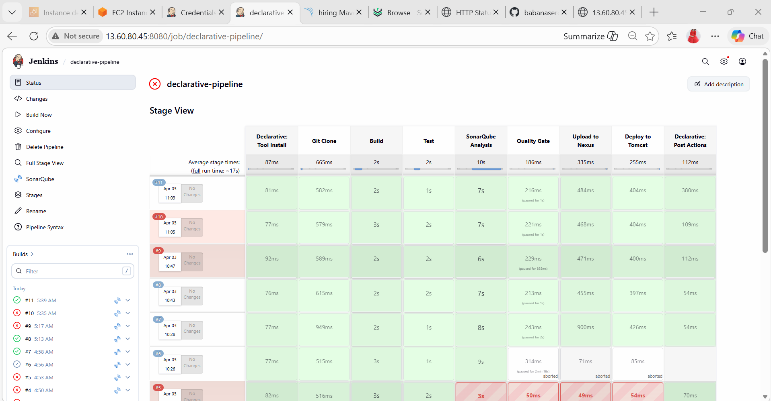

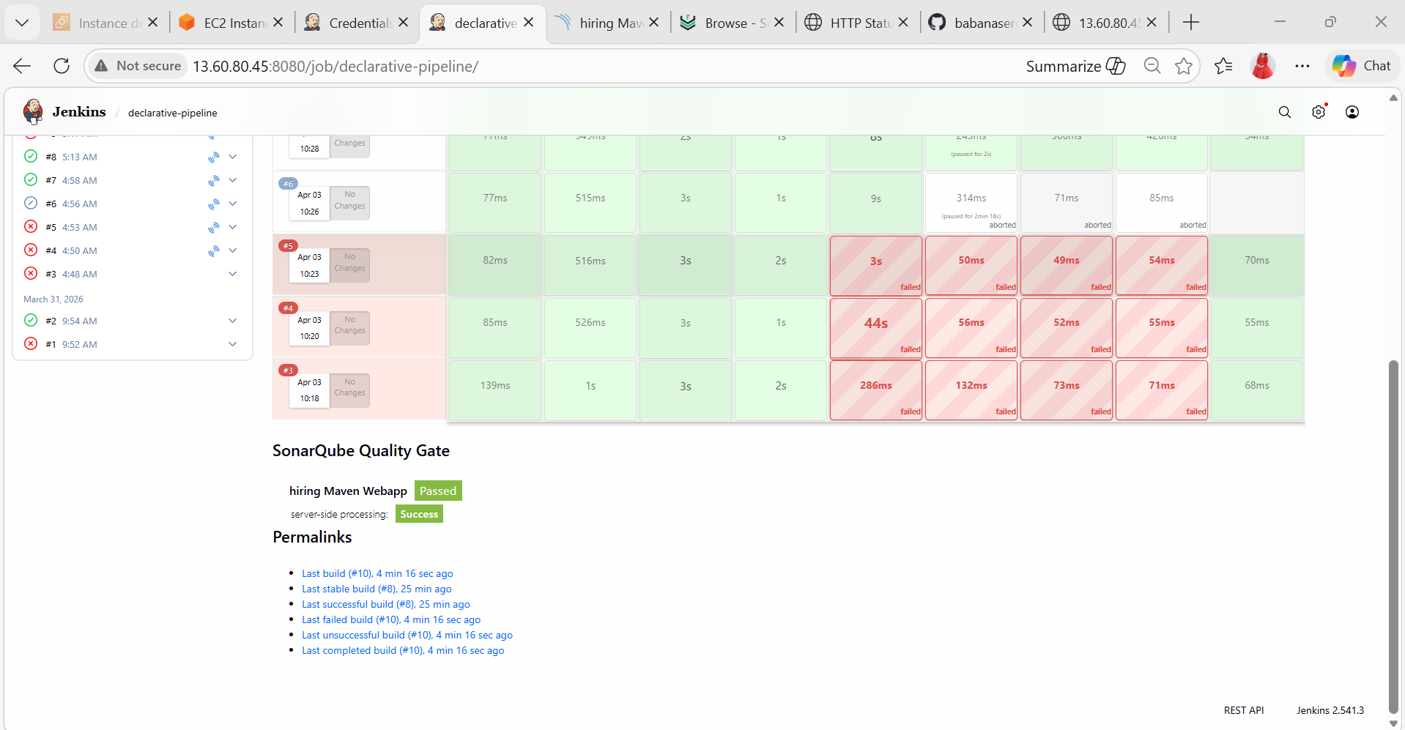
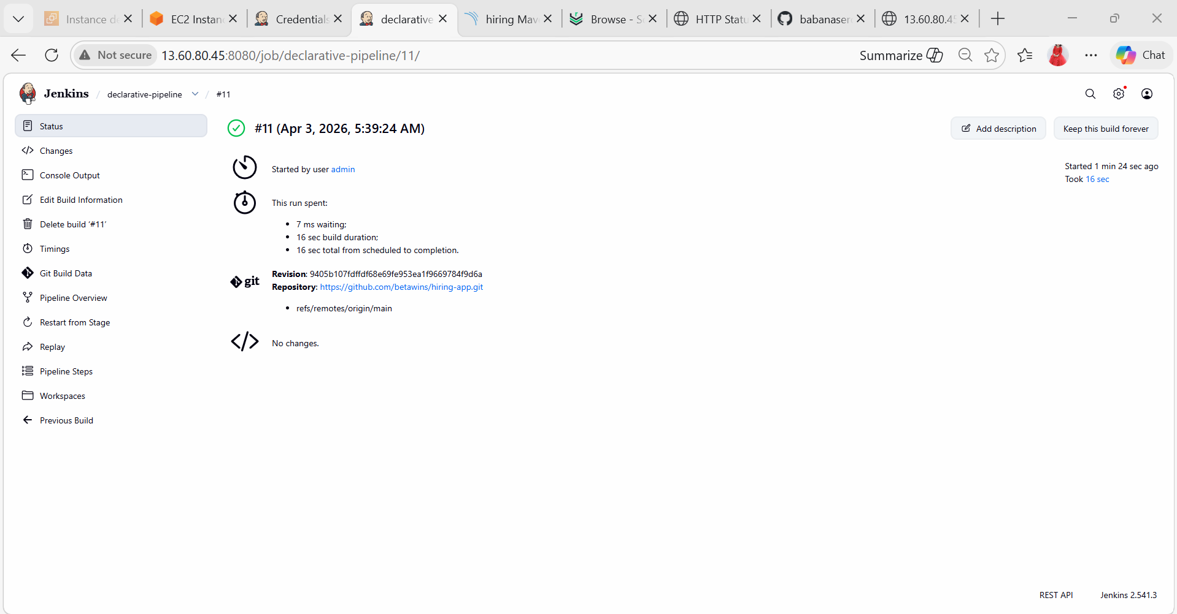

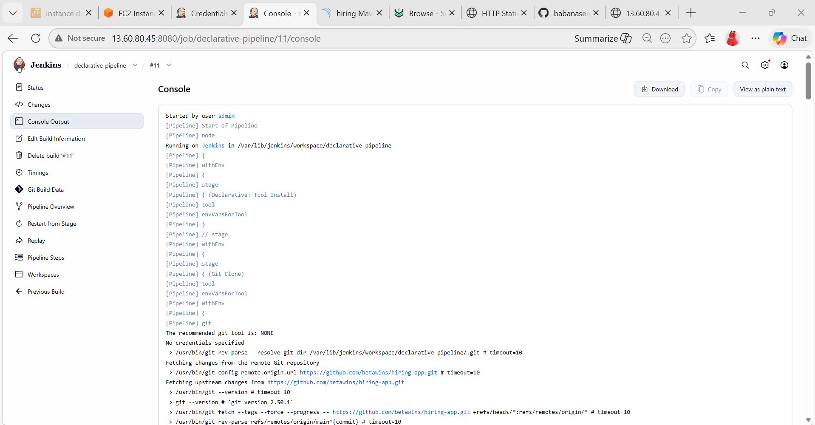
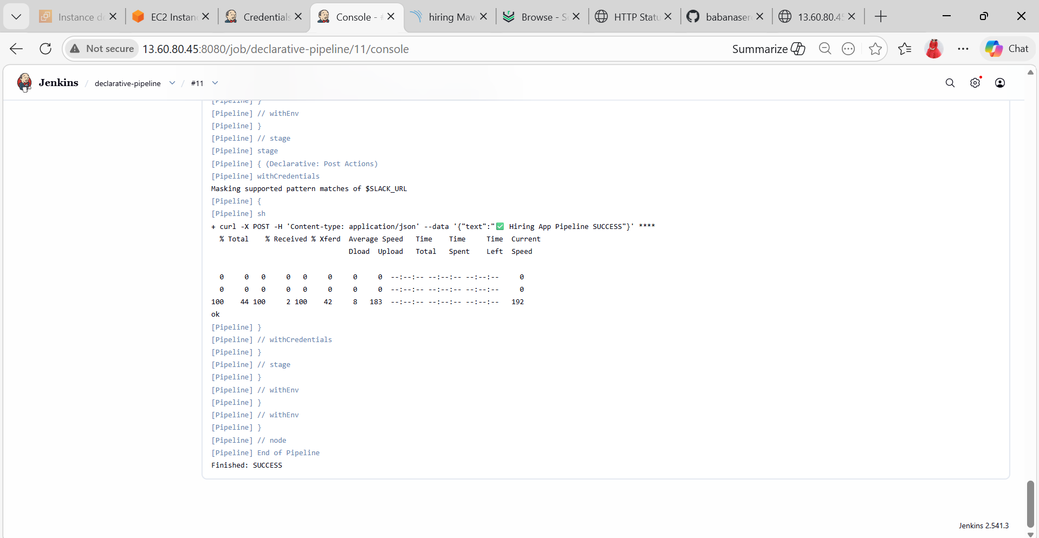

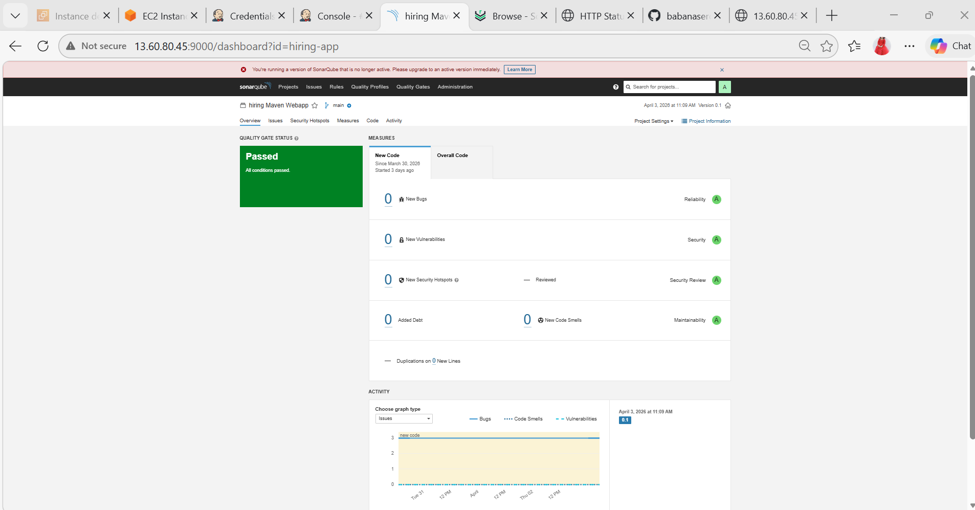

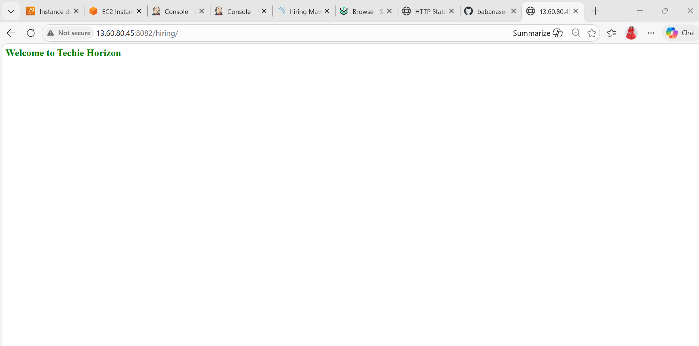

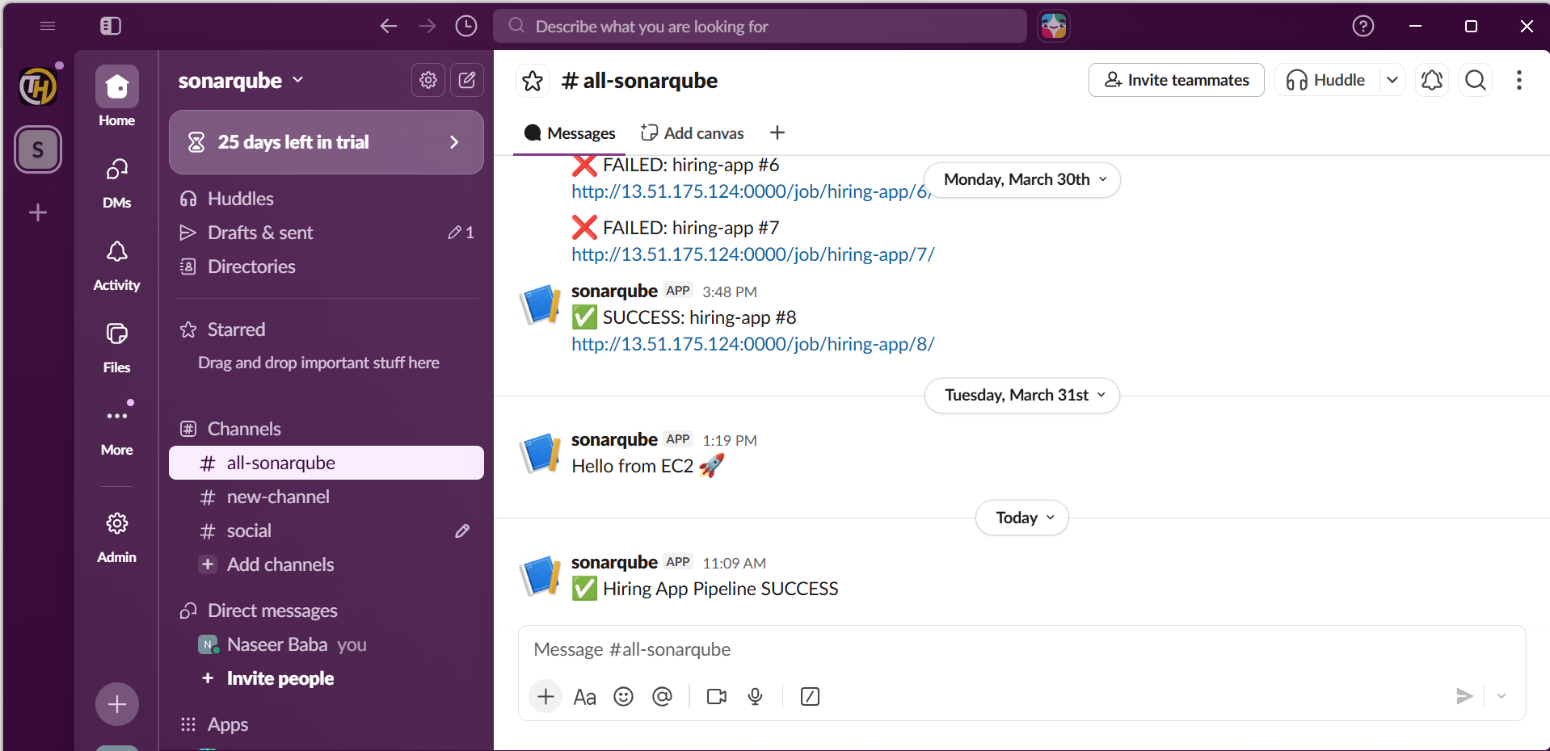

- Create one Scripted pipeline job
Prerequisites:
Make sure you have:
- Jenkins installed (on EC2 or local)
- Java installed
- Git installed
- Maven installed
- Nexus installed
- Tomcat installed
- Slack created
- Jenkins plugins:
Create New Job
1. Login to the Jenkins
2. Click New Item
3. Enter name: scripted-pipeline
4. Select Pipeline
5. Click OK
Add code to the pipeline:
node {
// Tool configuration
def mvnHome = tool name: 'Maven3', type: 'maven'
// Environment variables
env.NEXUS_URL = "http://13.60.80.45:8081"
try {
stage('Git Clone') {
git branch: 'main', url: 'https://github.com/betawins/hiring-app.git'
}
stage('Build') {
sh "${mvnHome}/bin/mvn clean package -DskipTests"
}
stage('Test') {
sh "${mvnHome}/bin/mvn test"
}
stage('SonarQube Analysis') {
withSonarQubeEnv('sonar') {
withCredentials([string(credentialsId: 'sonar-token', variable: 'TOKEN')]) {
sh """
${mvnHome}/bin/mvn sonar:sonar \
-Dsonar.projectKey=hiring-app \
-Dsonar.login=$TOKEN
"""
}
}
}
stage('Quality Gate') {
timeout(time: 3, unit: 'MINUTES') {
waitForQualityGate abortPipeline: true
}
}
stage('Upload to Nexus') {
withCredentials([usernamePassword(credentialsId: 'nexus-creds', usernameVariable: 'USER', passwordVariable: 'PASS')]) {
sh """
curl -u $USER:$PASS \
--upload-file target/*.war \
$NEXUS_URL/repository/maven-releases/in/javahome/hiring/1.0.${BUILD_NUMBER}/hiring-1.0.${BUILD_NUMBER}.war
"""
}
}
stage('Deploy to Tomcat') {
sh '''
CONTAINER=$(docker ps -qf "name=tomcat")
if [ -z "$CONTAINER" ]; then
echo "Tomcat container not running"
exit 1
fi
docker cp target/*.war $CONTAINER:/usr/local/tomcat/webapps/
'''
}
// SUCCESS NOTIFICATION
stage('Notify Success') {
withCredentials([string(credentialsId: 'slack-cred', variable: 'SLACK_URL')]) {
sh '''
curl -X POST -H 'Content-type: application/json' \
--data '{"text":"✅ Hiring App Pipeline SUCCESS"}' \
$SLACK_URL
'''
}
}
} catch (Exception e) {
// FAILURE NOTIFICATION
stage('Notify Failure') {
withCredentials([string(credentialsId: 'slack-cred', variable: 'SLACK_URL')]) {
sh '''
curl -X POST -H 'Content-type: application/json' \
--data '{"text":"❌ Hiring App Pipeline FAILED"}' \
$SLACK_URL
'''
}
}
throw e
}
}

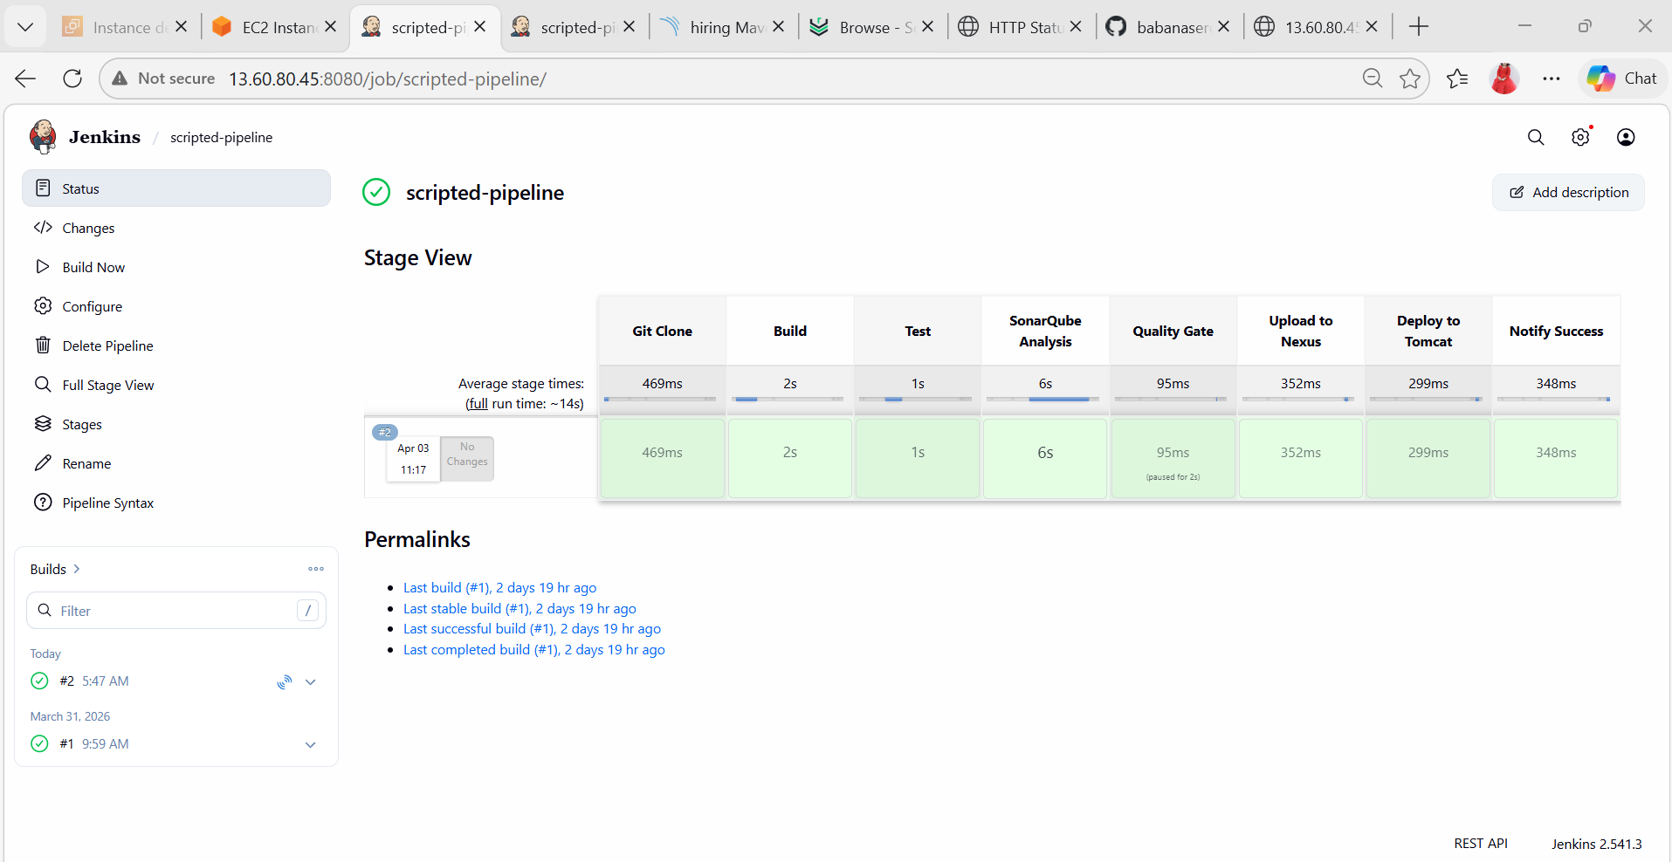

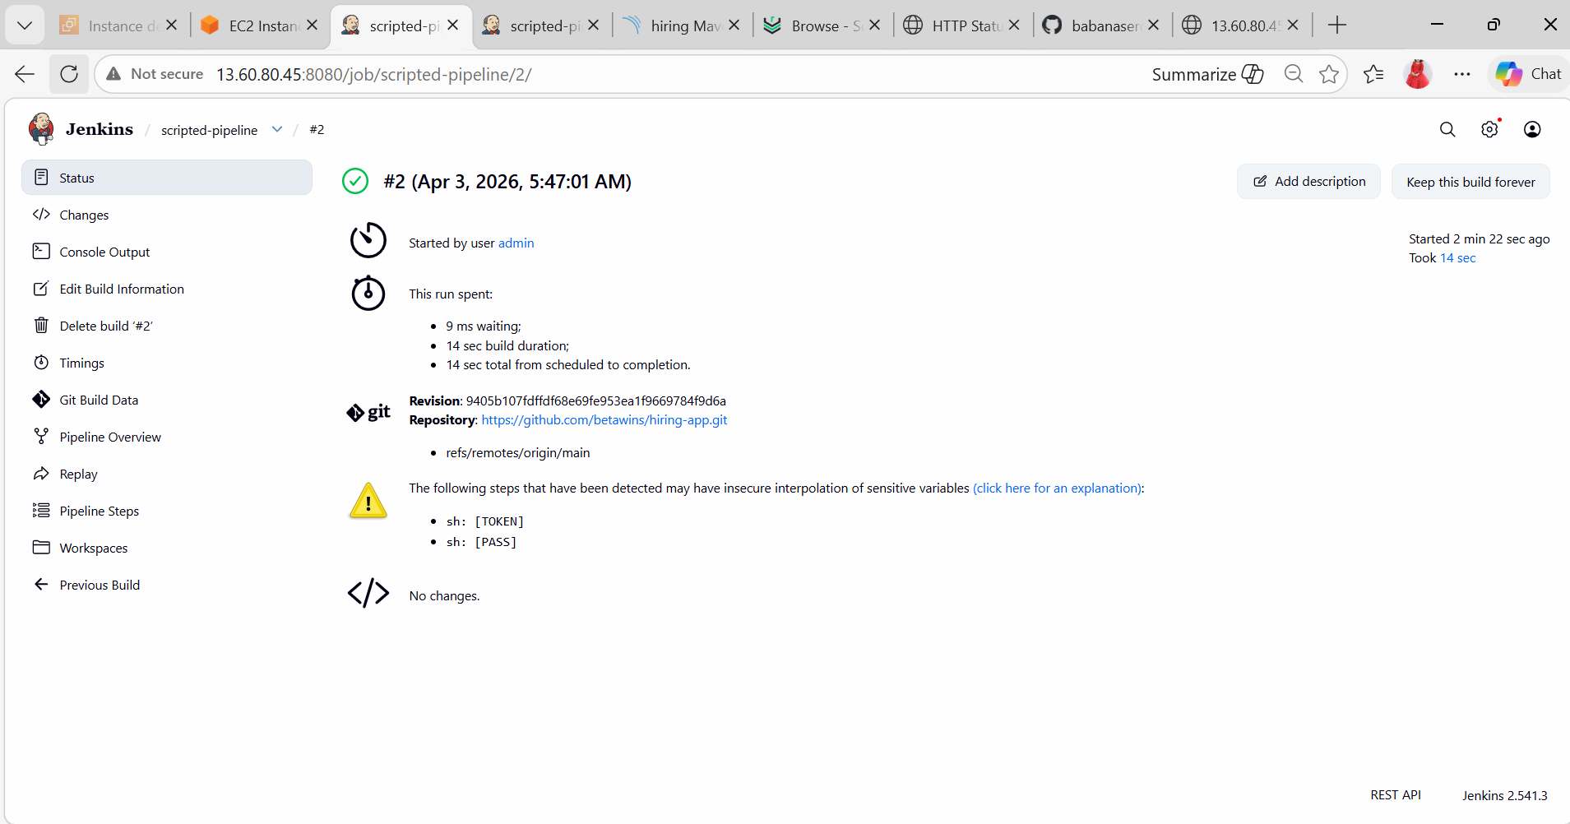

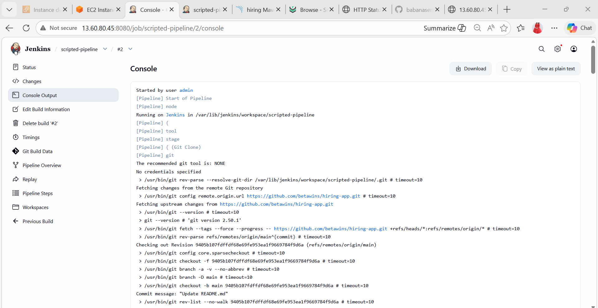

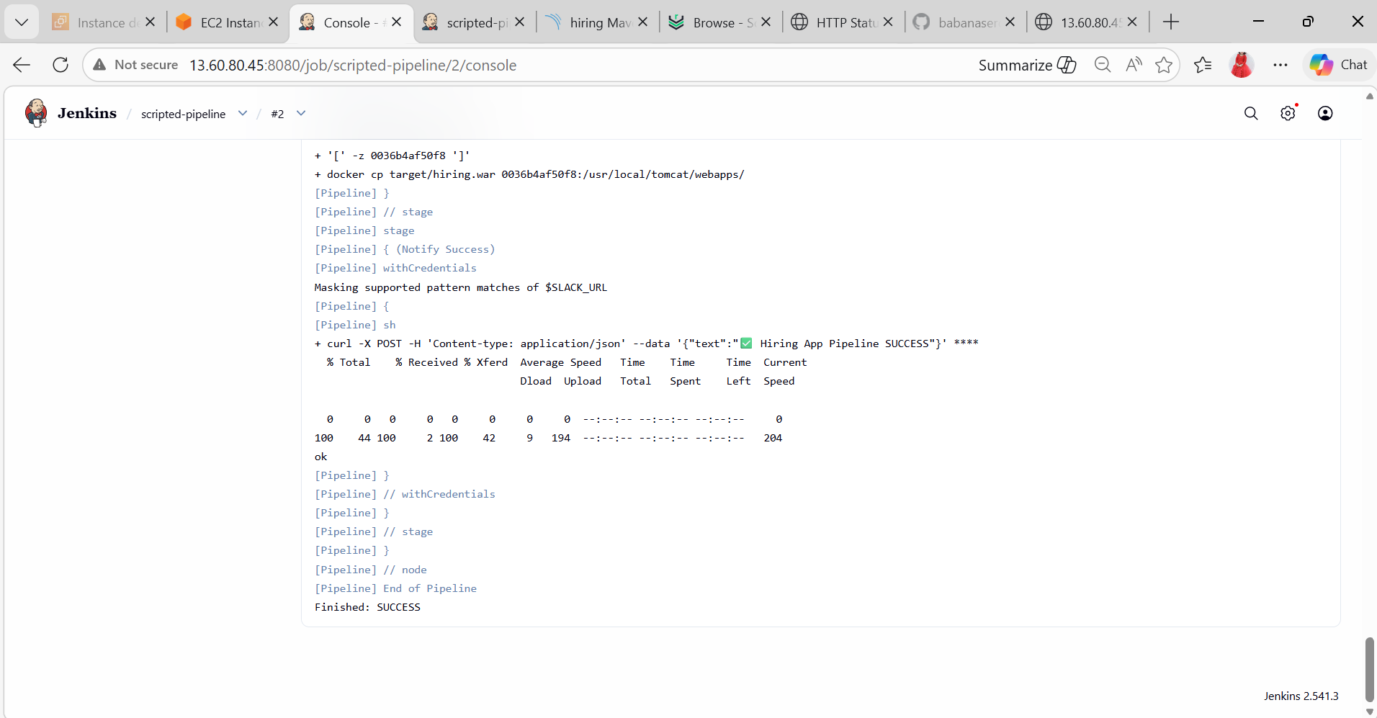

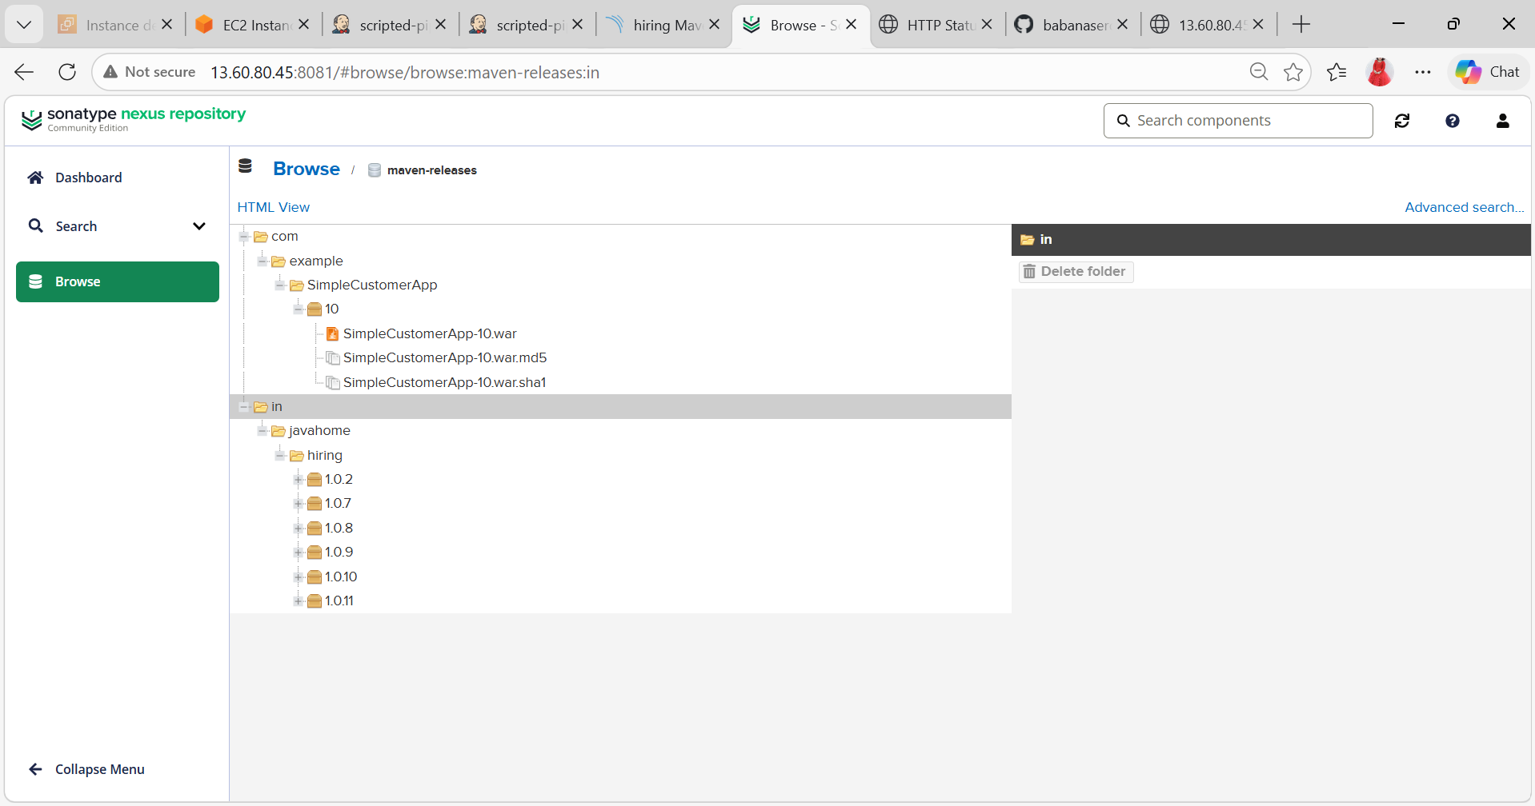

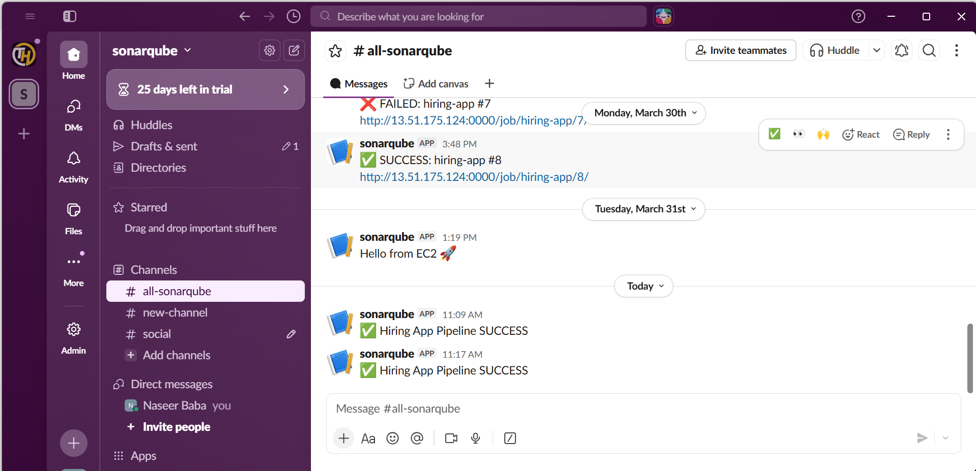
- Create one multi stage pipeline job
Prerequisites:
Make sure you have:
- Jenkins installed (on EC2 or local)
- Java installed
- Git installed
- Maven installed
- Nexus installed
- Tomcat installed
- Slack created
- Jenkins plugins:
Create New Job
1. Login to the Jenkins
2. Click New Item
3. Enter name: multistge-pipeline
4. Select Pipeline
5. Click OK

Add code to the pipeline:
pipeline {
agent any
tools {
maven 'Maven3'
}
environment {
NEXUS_URL = "http://13.60.80.45:8081"
VERSION = "1.0.${BUILD_NUMBER}"
}
stages {

stage('Clone') {
steps {
git branch: 'main', url: 'https://github.com/betawins/hiring-app.git'
}
}
stage('Build') {
steps {
sh 'mvn clean package -DskipTests'
}
}
stage('Test') {
steps {
sh 'mvn test'
}
}
stage('SonarQube Analysis') {
steps {
withSonarQubeEnv('sonar') {
withCredentials([string(credentialsId: 'sonar-token', variable: 'TOKEN')]) {
sh '''
mvn sonar:sonar \
-Dsonar.projectKey=hiring-app \
-Dsonar.host.url=http://13.60.80.45:9000 \
-Dsonar.login=$TOKEN
'''
}
}
}
}
stage('Quality Gate') {
steps {
timeout(time: 3, unit: 'MINUTES') {
waitForQualityGate abortPipeline: true
}
}
}
stage('Upload to Nexus') {
steps {
withCredentials([usernamePassword(credentialsId: 'nexus-creds', usernameVariable: 'USER', passwordVariable: 'PASS')]) {
sh '''
curl -u $USER:$PASS \
--upload-file target/hiring.war \
$NEXUS_URL/repository/maven-releases/in/javahome/hiring/${VERSION}/hiring-${VERSION}.war
'''
}
}
}
stage('Deploy to Tomcat') {
steps {
sh '''
CONTAINER=$(docker ps -qf "name=tomcat")
if [ -z "$CONTAINER" ]; then
echo "Tomcat container not running!"
exit 1
fi
docker cp target/hiring.war $CONTAINER:/usr/local/tomcat/webapps/
echo "Restarting container..."
docker restart $CONTAINER
'''
}
}
}
post {
success {
withCredentials([string(credentialsId: 'slack-cred', variable: 'HOOK')]) {
sh '''
curl -X POST -H 'Content-type: application/json' \
--data '{"text":"✅ Hiring App Pipeline SUCCESS"}' \
$HOOK || true
'''
}
}
failure {
withCredentials([string(credentialsId: 'slack-cred', variable: 'HOOK')]) {
sh '''
curl -X POST -H 'Content-type: application/json' \
--data '{"text":"❌ Hiring App Pipeline FAILED"}' \
$HOOK || true
'''
}
}
}
}

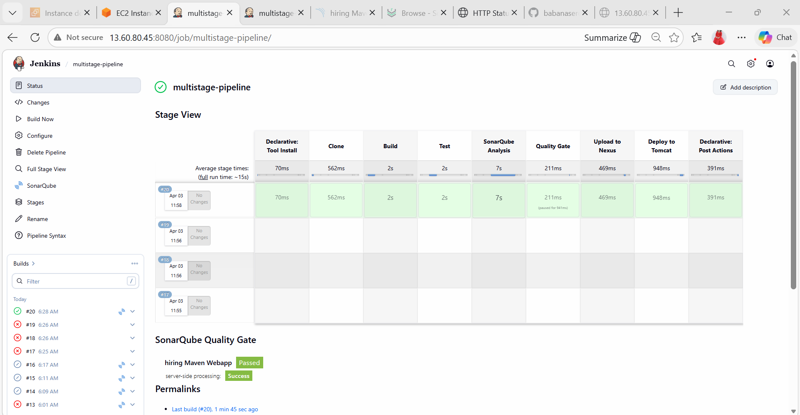

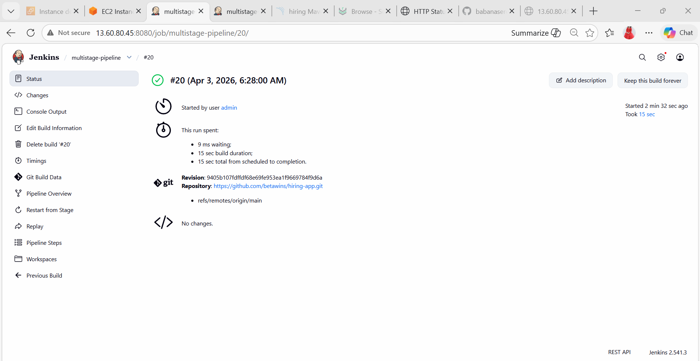

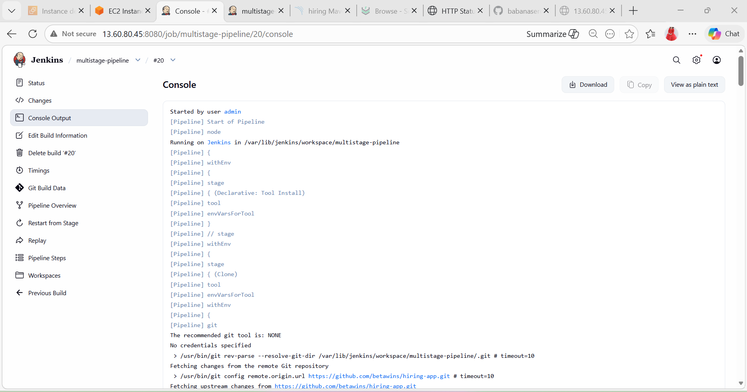

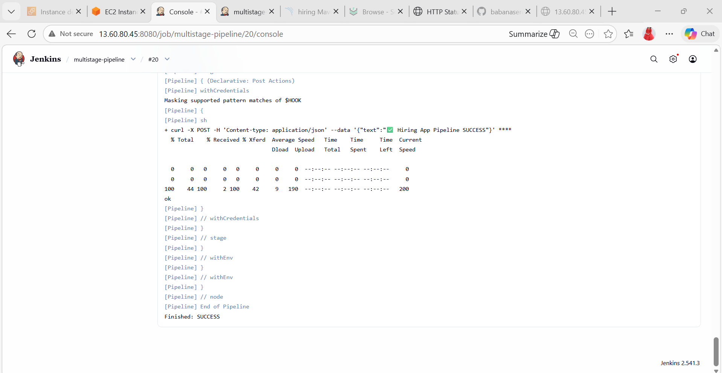

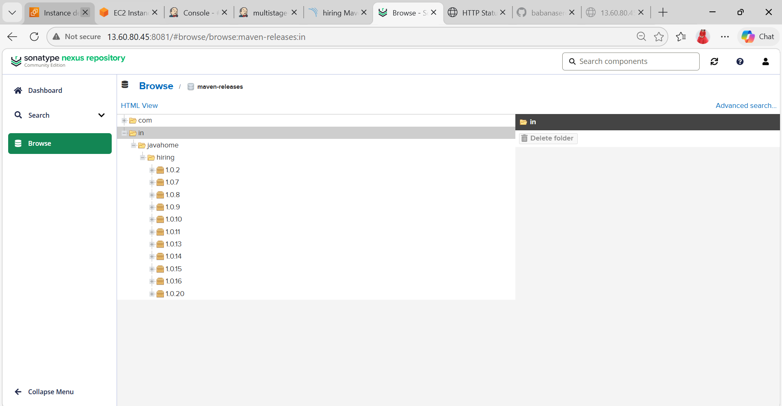

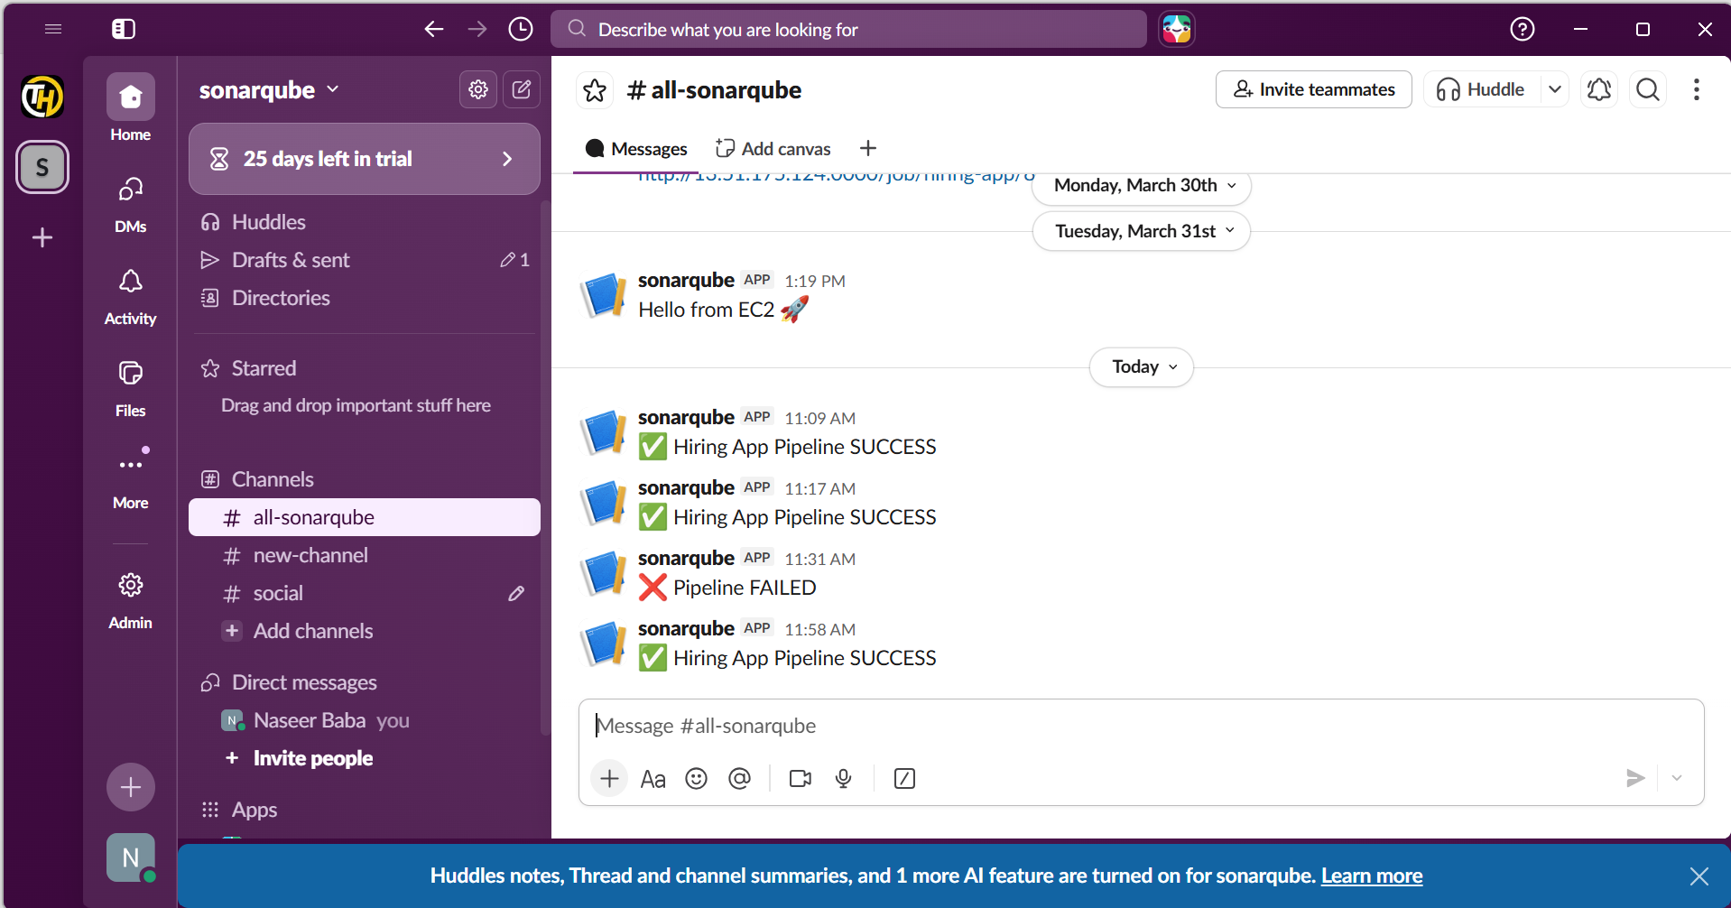
- Create one parallel stage pipeline job
Prerequisites:
Make sure you have:
- Jenkins installed (on EC2 or local)
- Java installed
- Git installed
- Maven installed
- Nexus installed
- Tomcat installed
- Slack created
- Jenkins plugins:
Create New Job
1. Login to the Jenkins
2. Click New Item
3. Enter name: parallelstage-pipeline
4. Select Pipeline
5. Click OK
Add code to the pipeline:
pipeline {
agent any
tools {
maven 'Maven3'
}
environment {
APP_NAME = "hiring-app"
NEXUS_URL = "http://13.60.80.45:8081"
VERSION = "1.0.${BUILD_NUMBER}"
}
stages {

stage('Clone') {
steps {
git branch: 'main', url: 'https://github.com/betawins/hiring-app.git'
}
}
stage('Build') {
steps {
sh 'mvn clean package -DskipTests'
}
}
stage('Parallel Testing') {
parallel {
stage('Unit Tests') {
steps {
sh 'mvn test'
}
}
stage('SonarQube Analysis') {
steps {
withSonarQubeEnv('sonar') {
withCredentials([string(credentialsId: 'sonar-token', variable: 'TOKEN')]) {
sh '''
mvn sonar:sonar \
-Dsonar.projectKey=hiring-app \
-Dsonar.host.url=http://13.60.80.45:9000 \
-Dsonar.login=$TOKEN
'''
}
}
}
}
stage('Security Scan') {
steps {
echo "Running security scan..."
// Example: trivy fs .
}
}
}
}
stage('Quality Gate') {
steps {
timeout(time: 3, unit: 'MINUTES') {
waitForQualityGate abortPipeline: true
}
}
}
stage('Check Artifact') {
steps {
sh 'ls -l target/'
}
}
stage('Upload to Nexus') {
steps {
withCredentials([usernamePassword(credentialsId: 'nexus-creds', usernameVariable: 'USER', passwordVariable: 'PASS')]) {
sh '''
curl -u $USER:$PASS \
--upload-file target/*.war \
$NEXUS_URL/repository/maven-releases/com/example/hiring-app/${VERSION}/hiring-app-${VERSION}.war
'''
}
}
}
stage('Deploy to Tomcat') {
steps {
sh '''
CONTAINER=$(docker ps -qf "name=tomcat")
if [ -z "$CONTAINER" ]; then
echo "Tomcat container not running"
exit 1
fi
docker cp target/*.war $CONTAINER:/usr/local/tomcat/webapps/
'''
}
}
stage('Verify Deployment') {
steps {
echo "App deployed at: http://13.60.80.45:8082/hiring-app"
}
}
}
post {
success {
withCredentials([string(credentialsId: 'slack-cred', variable: 'HOOK')]) {
sh '''
curl -X POST -H 'Content-type: application/json' \
--data '{"text":"✅ HiringApp Pipeline SUCCESS 🚀"}' \
$HOOK || true
'''
}
}
failure {
withCredentials([string(credentialsId: 'slack-cred', variable: 'HOOK')]) {
sh '''
curl -X POST -H 'Content-type: application/json' \
--data '{"text":"❌ HiringApp Pipeline FAILED ❗"}' \
$HOOK || true
'''
}
}
}
}
